user software requirements specification

PA Historical Finder

Harrisburg University of Science and Technology

CISC 397, Spring 2018

By Shannon Williams, Daniel Malinsky, Raekwon Harley, Edward Sampson, Sujan Tanniru

Table of Contents

1. Introduction 2

1.1. Purpose 2

1.2. Intended Audience 2

2. User Requirements 2

2.1. Glossary 2

2.2. Use Cases Overview 3

2.3. Use Cases In-Depth 3

2.3.1. US 1- First Time User Authentication 3

2.3.2. US 2 – Existing User Authentication 4

2.3.3. US 3 – User Tagging 5

2.3.4. US 4 – Historical Information Searching 6

2.3.5. US 5 – User Session Termination 6

# Introduction

## Purpose

This document serves to explain the user requirements for the software desired.

## Intended Audience

Persons who have an interest in the understanding of the behavior of the system may read this document.

# User Requirements

## Glossary

**User** – The primary actor; A person who will be using the system for it’s services.

**UC –** Use Case.

**System** – Used interchangeable for the software that will be developed.

**Tagging** – Saving an item to a User defined list.

**Item** – Any object that represents a historical piece of information.

**Customers** – Individual persons who pay to use the system’s service.

**KYC** – Know Your Customer

## Use Cases Overview

User requirements will be defined using Use Cases – describing the interaction between actors and the desired system. Figure 1.0 shows a visual representation of an overview of all Use Cases.

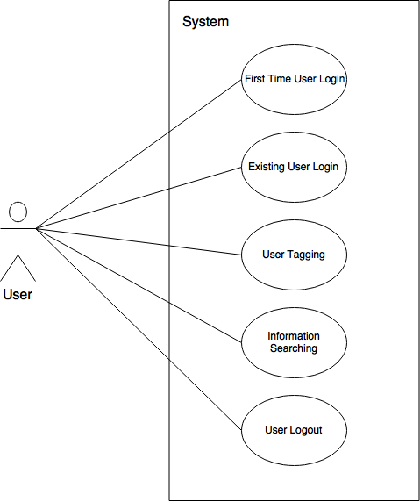

**Figure 1.0 – Use Case Overview Diagram**

### Use Cases In-Depth

## US 1- First Time User Authentication

**Primary Actor:**User

**Stakeholders (Other Interested Actors):**

* Future Security Team – Would like to see some form of membership framework in place to facilitate future security policy developments.

**Description:** To Explain the process in which the system should respond to a new User (someone who is not registered with the system)

**Main Success Flow:**

1. A new User desires to access the system for the first time so he/she tries to access the system’s services.
2. The system must recognize the User is not recognized.
3. User will be prompted to register with the system using user defined credentials.
4. User enters and submits credentials to the system, which then register the User.
5. System then automatically authenticates the User and gives access to system services.

**Pre-conditions:**

* User must not be registered with the system.

**Post-conditions (always happen after):**

* User will be registered and be recognized by the system in subsequent authentication attempts with User credentials.

**Special Requirements:**

* The mechanisms for recognizing the User in subsequent authentication requests must not at any time transfer the User’s password across the network.

**Frequency of Occurrence:**

* Higher occurrences shortly following marketing efforts on media platforms.

## US 2 – Existing User Authentication

**Primary Actor:**User

**Stakeholders (Other Interested Actors):**

* Future Security Team – Would like to see some form of membership framework in place to facilitate future security policy developments.
* Software Owners – This entity does not want unauthorized individuals gaining access to system resources and insist on compliance with related policies.

**Description:** To Explain the process in which the system should respond to a User trying to authenticate himself/herself to gain access to system services.

**Main Success Flow:**

1. User wants to authenticate himself/herself in order to use the system’s services. The User uses the system provided interface to enter authentication credentials.
2. User submits the credentials which the system receives and validate.
3. Upon successful validation, the system gives access to the User for use of system services.

**Pre-conditions:**

* User must not be currently authenticated with system.
* User must already be registered with a set of credentials.

**Post-conditions (always happen after):**

* User will be recognized by the system in subsequent authentication attempts with User credentials.

**Special Requirements:**

* The mechanisms for recognizing the User in subsequent authentication requests must not at any time transfer the User’s password across the network.

**Frequency of Occurrence:**

* Higher occurrences shortly following marketing efforts on media platforms.

## US 3 – User Tagging

**Primary Actor:**User

**Stakeholders (Other Interested Actors):**

* Software Owners – This entity wants to ensure that users have convenient functionality as an incentive to retain customers.

**Description:** To Explain the process in which Users can tag historical information unto a list that the User owns.

**Main Success Flow:**

1. User wants to tag and item to a list. The User selects a historical item displayed by the system and notifies intent to add item to a list.
2. The system then prompts the user for the desired list from the set of lists created by the same User.
3. User then selects a list from the set and notifies the system to add the selected item to the chosen list.
4. System then saves the item to the list.

**Pre-conditions:**

* User must be currently authenticated with system.
* User must have already defined lists within the system.

**Post-conditions (always happen after):**

* After adding, the User will be able to see the item in the list within 10 seconds or when requesting the updated list.
* The lists along with items must be saved persistently. I.e. the list and its items must be available and visible to the User on subsequent uses.

**Special Requirements:**

* The User shall be able to add the item to a list in no more than 3 clicks after selecting the item.

**Frequency of Occurrence:**

* At least half the time the user will be using the system services.

**Alternate Flow:**

* 1. – No tag list exists for User

1. System gives User the option to add a new list by defining and submitting a desired name.
2. User then selects the item to add.
3. User then selects a list to add the item to and continue to 4.)

## US 4 – Historical Information Searching

**Primary Actor:**User

**Stakeholders (Other Interested Actors):**

* Software Owners – This entity wants to ensure that users have convenient functionality as an incentive to retain customers.
* KYC Campaign Personnel – Would like some records of what Users are searching for, the time periods of search, and the results they receive. The data can be useful for KYC efforts, usually under the umbrella of marketing.

**Description:** To Explain the process in which Users can search historical information within the system.

**Main Success Flow:**

1. User wants to tag and item to a list. The User selects a historical item displayed by the system and notifies intent to add item to a list.
2. The system then prompts the user for the desired list from the set of lists created by the same User.
3. User then selects a list from the set and notifies the system to add the selected item to the chosen list.
4. System then saves the item to the list.

**Pre-conditions:**

* User must be currently authenticated with system.

**Post-conditions (always happen after):**

* After adding, the User will be able to see the item in the list within 10 seconds or when requesting the updated list.
* The lists along with items must be saved persistently. I.e. the list and its items must be available and visible to the User on subsequent uses.

**Special Requirements:**

* Searching and search results are only limited to historical information within Pennsylvania.

**Frequency of Occurrence:**

* At least half the time the user will be using the system services.

## US 5 – User Session Termination

**Primary Actor:**User

**Stakeholders (Other Interested Actors):**

* Future Security Team – Would like to see some form of membership framework in place to facilitate future security policy developments.

**Description:** To Explain the process in which Users can end their session where as they will have to re-authenticate themselves to access system services.

**Main Success Flow:**

1. User wants to end their current session. User then proceeds to notify the system to terminate current session.
2. The system processes ending of current session.
3. User’s session is no longer valid and must re-authenticate himself/herself to gain access to system services.

**Pre-conditions:**

* User must be currently authenticated with system.

**Post-conditions (always happen after):**

* Any CRUD like operations the system has process for the user during the most recent active session, will be saved persistently and be available and visible to user for next session.

**Special Requirements:**

* The system must take no longer than 10 seconds in processing termination of a session.

**Frequency of Occurrence:**

* 1/3 of the time of sessions for a User